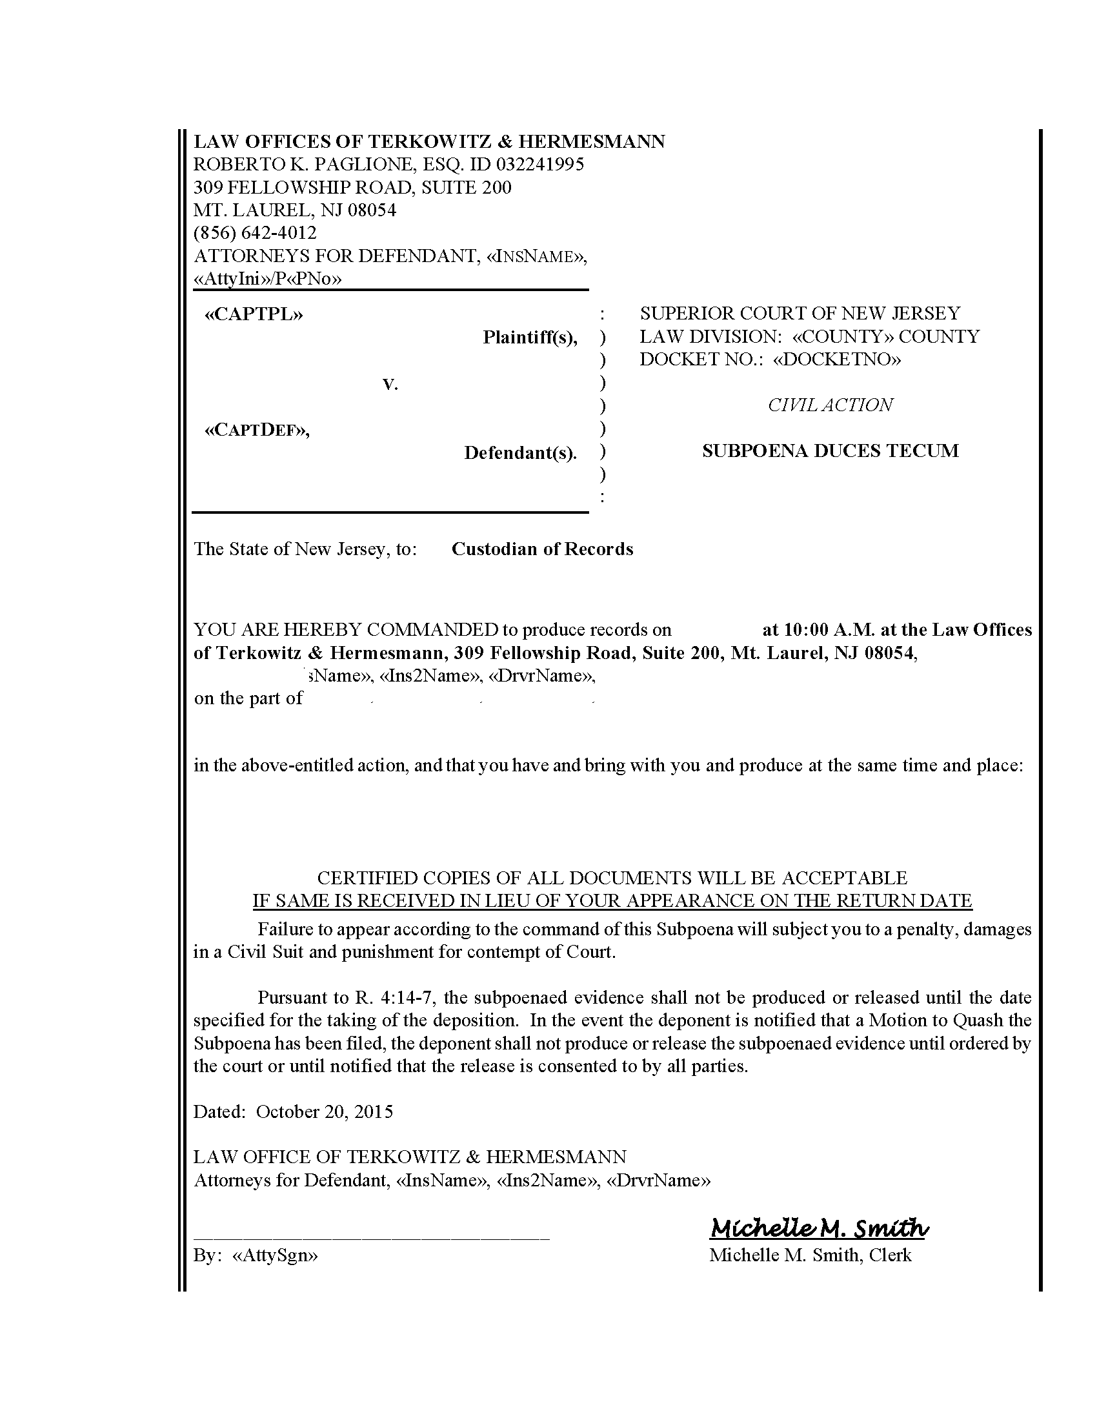
(S) John Dangelis

George Carey and Linda Carey
Giannone Services, Inc. and John Dangelis
Montgomery
2015-15055
John Dangelis
FROM 05/21/1949 TO PRESENT: Any and all MEDICAL RECORDS, including but not limited to patient history form(s), reports, etc. pertaining to George Carey SSN: xxx-xx-1613, DOB: 05/21/1949.
(s) John Dangelis
David Pizzica
Order Number: 01-36113-001
Lucas and Cavalier, LCC
David Pizzica, ID #: 308937
1500 Walnut Street Suite 1500
Philadelphia, PA 19102-0000
(215) 751-9192
Lucas and Cavalier, LCC, David Pizzica
C/O Axiom Requisition Copy Service 2869 Jolly Road Okemos, MI 48864
Lucas and Cavalier, LCC
CUSTODIAN OF RECORDS
Einstein Medical Center Montgomery
559 West Germantown Pike
East Norriton, PA 19403-0000
02/21/16

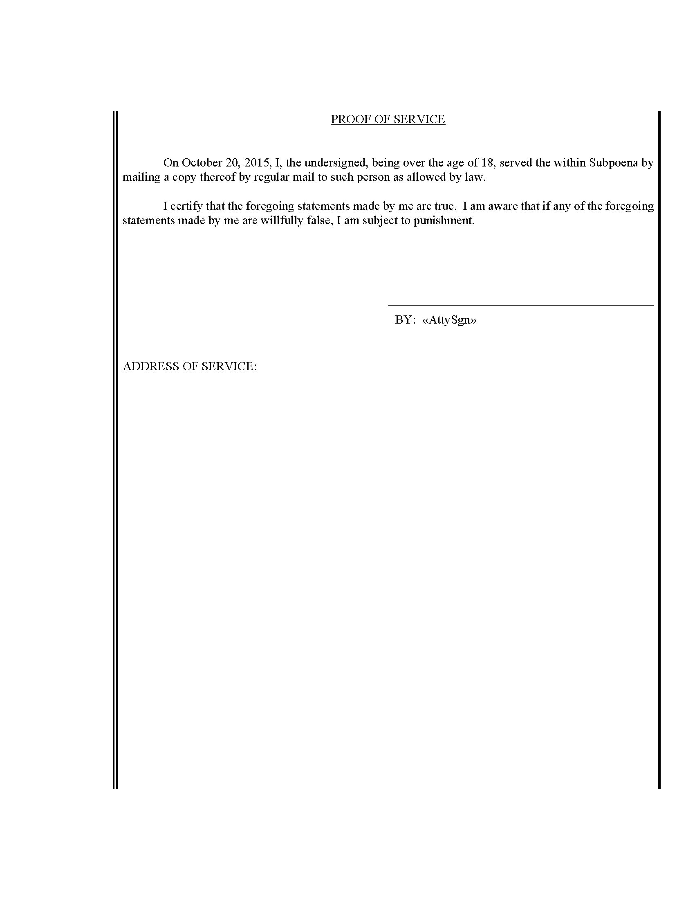
David Pizzica
Order Number: 01-36113-001
CUSTODIAN OF RECORDS
Einstein Medical Center Montgomery
559 West Germantown Pike
East Norriton, PA 19403-0000

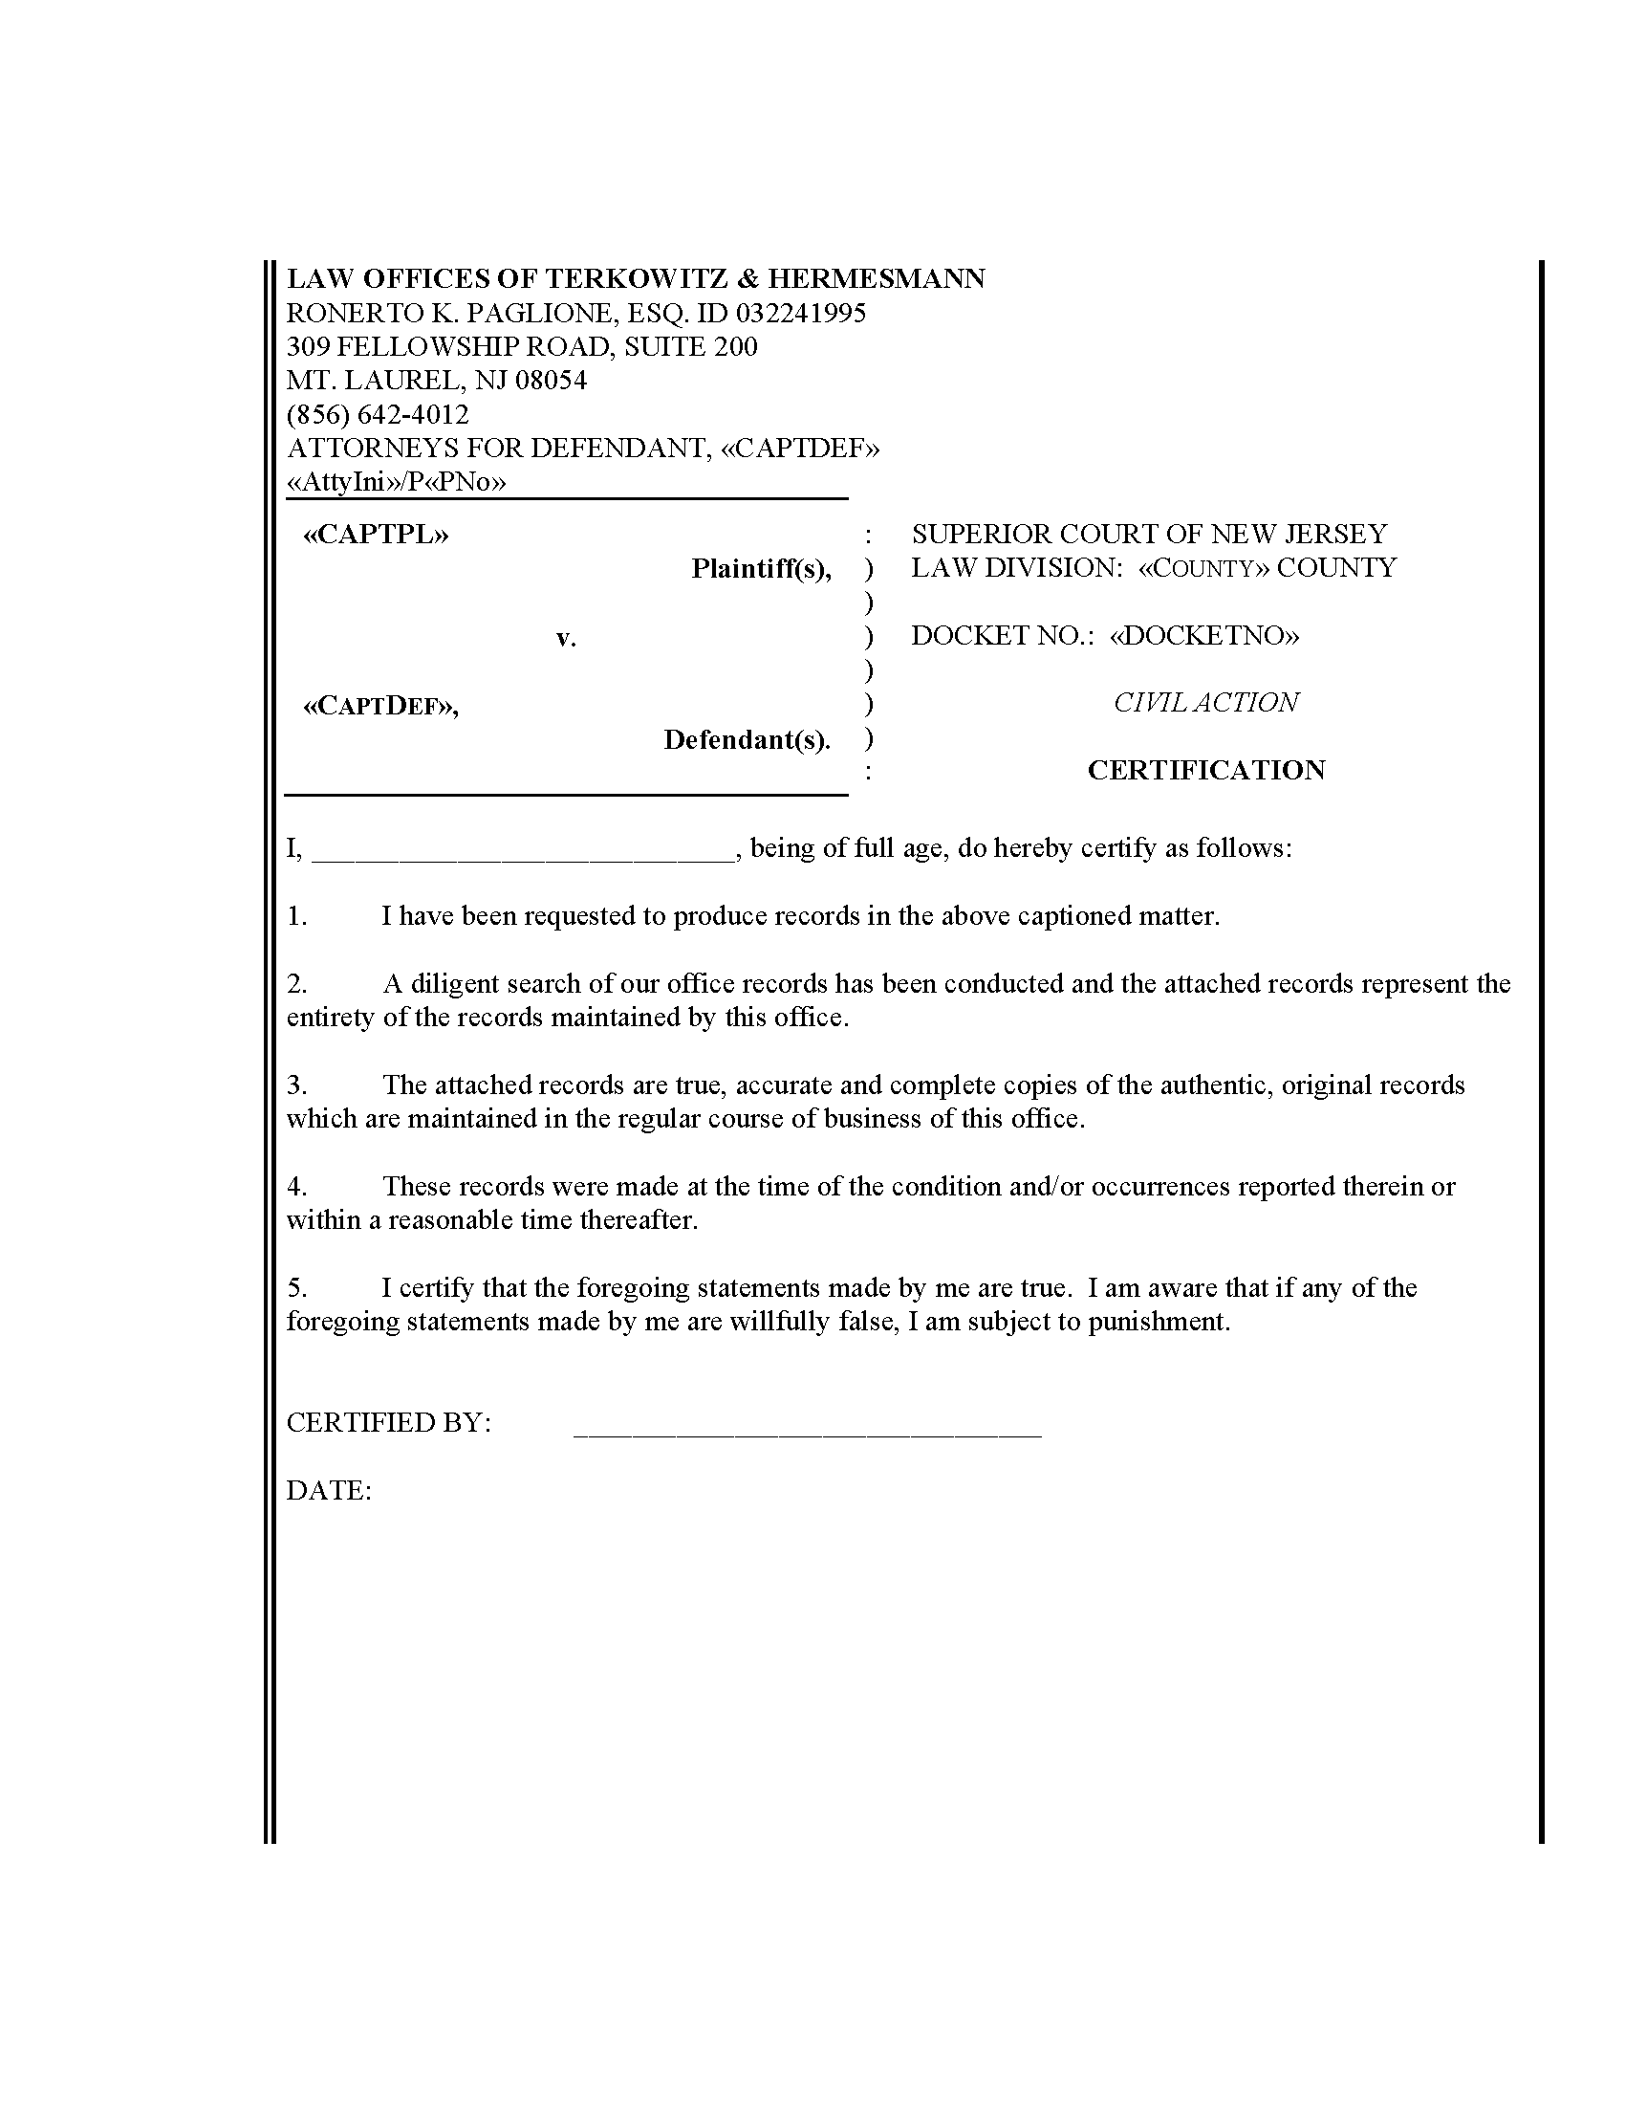

George Carey and Linda Carey
Giannone Services, Inc. and John Dangelis
Montgomery
2015-15055
Order Number: 01-36113-001
Lucas and Cavalier, LCC
David Pizzica, ID #: 308937
1500 Walnut Street Suite 1500
Philadelphia, PA 19102-0000
(215) 751-9192
(S) John Dangelis

